A kind of linear structure segmentation method for medical image object
Yexiu Fen Yajun Yang

1. Academy of Mathematics and Systems Science, Chinese Academy of Sciences, Beijing 100190
E-mail: ccc@amss.ac.cn
2. Harbin Engineering University, Harbin 150001, China
E-mail: xxx@heu.edu.cn

Abstract: In many medical imaging applications, the extraction of linear structure like vblood capillary in vascular images or axon and dendrite in neuroimage is of important significance. Since the extraction of linear structure in medical image using global threshold algorithm accompanies with the problem of linear discontinuities and serious noise confusion. We propose a connected domain based linear structure segmentation method for medical images, which takes full advantage of the linear smoothing and enhancecharacteristics of steerable filter, as well as the strength of better connectivity of linear structure when processing images with smooth boundary using local threshold segmentation method. Finally, we proposed a connected-domain based image binarization segmentation method for linear structure. The corresponding experimental results show that the methods proposed in this paper can guarantee the linear connection characteristics well with inhibited noise greatly.

Key Words: linear structure; Steerable filter; threshold; connected domain

- Introduction
The segmentation of linear structure object, such as the retina, capillary and nerve axon and dendrite, have important significance in medicine image. There is no general segmentation algorithm for the linear structure of the medical image, such as blood vessels, nerves axon and dendritics because of the complexity of the original images and the characteristic of uneven intensity distribution and the tremendous changes in density. Typical segmentation algorithms, such as region growing algorithm [1,2,3], matched filtering algorithm[4,5] and the level set algorithm[6] have been successfully applied in image segmentation of blood vessels, however, these segmentation algorithms do not fit for those neural images with axons and dendrites which have weak connectivity, uneven gray-level and unconspicuous tubular structures.
T.Freeman[7] summaried the mathematical theory and design algorithms of the steerable filters. M.Jacob[8] proposed the design principle of steerable filter based on Canny similarity criterion. The steerable filter algorithm based on Gaussian kernel can better smooth and enhance the image with linear structures. Threshold algorithm is the basic algorithm of image segmentation, which can be divided into global threshold algorithm and local threshold algorithm. However, common global threshold algorithms， such as Otsu algorithm [9], cannot maintain the connectivity of the linear structure very well. Local threshold algorithms such as NiBlack algorithm [10, 11], are effective for the segmentation of text-based image, however, for non-text-based image segmentation, this kind of algorithm will cause a large number of dichotomous noise.
This paper designs several segmentation algorithms based on connected domain to extract the linear structure in medical images, which takes full advantage of the linear smoothing and enhance features of steerable filter based on Gaussian kernel, as well as the strength of better linear structure connectivity when processing images with smooth boundary using local threshold segmentation method.
Section II introduces the steerable filter algorithm and points out the specific basic kernel functions we select for the later experiment. Section III presents the design principles of the proposed algorithm in this paper. By the experiments compared with the level set algorithm, K-means algorithm and etc in section IV, we make a summary in section IIV.
- Steerable Filter
In summarizing the design principles of steerable filters, reference [7] points out that the steerable filter is based on the function of polar coordinates in the form of Fourier series expansion. The purpose of this process is to express the steerable filter as the linear combination of the arbitrary direction of the basic filter function. Because the convolution is a linear operation, we express the steerable filter function with a group of basic filter functions after filter response in the form of linear combination. It avoids a lot of repetitive convolution operations, reduces the amount of computation and improves the efficiency of computing. Steerable filter is generally expressed as follows:
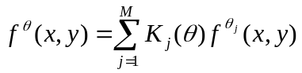 (1)
where,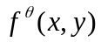 is the steerable filter and is the direction. 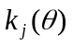is the J-th interpolation function. M is the number of the basic filter functions. 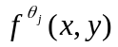 is the J-th basic filter function of the steerable filter in direction .
Interpolation function normally follows the following constraints:
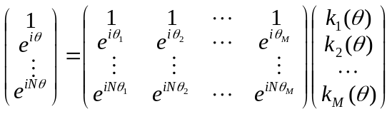 (2)
The derivative of Gaussian function can be expressed as the multiplication of circularly symmetric window function and a polynomial , so researchers often use Gaussian function as the basic filter function to construct the steerable filter.
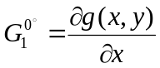 (3)
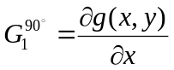 (4)
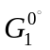and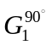are functions in the directions of 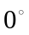and 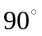respectively. The steerable filter function in any direction can be determined by the linear combination of the two basic functions of formula (3) and (4) . shown as follows,
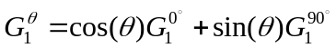 (5)
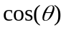and 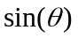corresponding to the interpolation functions.
The experiments in this paper for the steerable filter are based on the second derivative Gaussian function and the normalized Gaussian function is as follows.
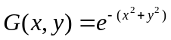 (6)
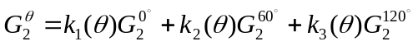 (7)
And 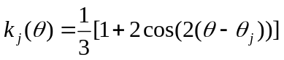 (8)
Fig 1 shows the filtering effect of the steerable filter algorithm based on the Gaussian kernel. From Fig 1(b), we can see that the steerable filter algorithm can enhance the connectivity and restrain noise of the image effectively. It makes preparation for the further extraction of the linear structure for the medical images.

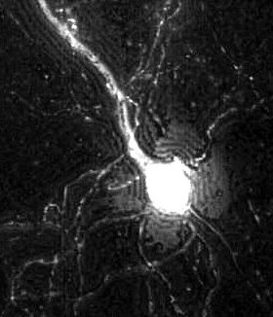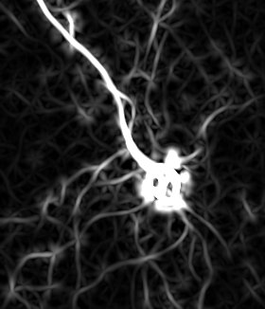
(a)xxxx (b)xxxxx
Fig. 1: Steerable filter

- Our Approach
  - Threshold algorithm analysis
Threshold algorithm can be generally divided into global threshold algorithm and local threshold algorithm. Global threshold segmentation algorithmA fixed threshold T in an image is adopted in Global threshold segmentation algorithm, such as Otsu algorithm, maximum entropy algorithm and gray expectation algorithm. Local threshold algorithm can be divided into threshold segmentation algorithm based on a block and neighborhood-based segmentation algorithm, such as NiBlack algorithm, Sauvola algorithm and Feng algorithm, these algorithms have been effectively used for text-based images.

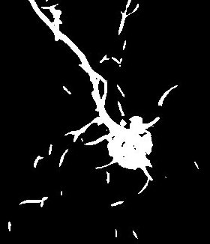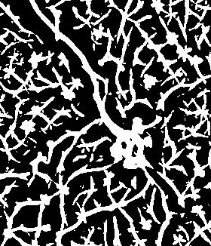
Fig 2: Threshold algorithm

As shown in Fig 2 which shows the results of the Otsu global threshold and the NiBlack local threshold algorithm for Fig 1(b), we find that global threshold algorithm cannot guarantee the connectivity of the linear structure, which is not conducive to the later image reconstruction. The local threshold algorithm like NiBlack can guarantee the connectivity of the linear structure, but the algorithm causes a large number of false linear structure information. Therefore, we proposed a new method combining the traditional Otsu algorithm and NiBlack algorithm. Firstly, we process the original image with the steerable filter algorithm, secondly, we use Otsu algorithm and NiBlack algorithm to segment the image processed by the steerable filter algorithm separately. Making statistics of connected domain of the binary image processed by the NiBlack segmentation algorithm, we regard the results of the binarization segmentation of Otsu algorithm as a “referee" to decide which connected-domain of NiBlack segmentation should “leave or stay”. Thus, we propose an idea of “Connected-domain Threshold”. The specific algorithm is as below.
  - Connected domain marking
In this paper, the Depth First Traversal(DFS) algorithm is used to mark the connected-domain of the image pre-processed by the NiBlack algorithm. Because function recursion may cause stack overflow, so we set up the longest connected-domain 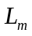being 500 pixel points in the experiment of this paper, as shown in the following,
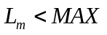 (9)
where, 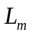is the longest length of the connected domain allowed to mark. MAX is the maximum permissible value that may cause stack overflow.
In the experiment of this paper, the image to be marked is binary image and the marked pixels are foreground (pixel value is 255). In the marking process, we make statistics through the establishment of a one-dimensional array A and the subscript represents the marked value and the value of the array stores the length of the corresponding connected domain. In order to make the array subscript correspond to the marking results, the binary image(0,255) is converted to the binary image(0, 1) which will be marked on the pixels with value 1. We regard 2 as the starting number of marking. As shown in Fig 3.

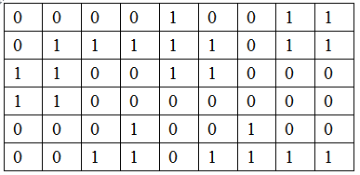
(a) NiBlack
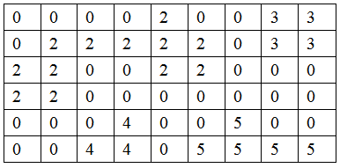
(b) Connected-Domain Marking
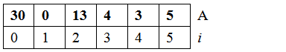
(c))Statistics of Connected Domain

Fig 3: Connected-Domain Marking & Statistics
  - Statistics of Marked Image and Otsu Image
Otsu algorithm cannot maintain the connectivity of the linear structure of the image, but it can basically separate foreground from background. To take advantage of this feature, we count the pixel number of foreground of Otsu image corresponding to the marked image(Fig 3(b)). As below is the specific method.
As shown in Fig 4(b), we create a one-dimensional array B that has the same length and the same subscript meaning with the array in Fig 3(c). Scanning the Otsu image, just as shown in Fig 4(a), if the value f(x,y) is 1, the value B(i) of the array B increases by one and i is the marked number at the corresponding position (x,y) just as shown in Fig 3(b).

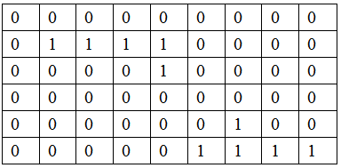
(a) Otsu
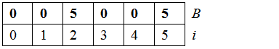
(b) Statistics of Otsu & Marked Image

Fig 4: Statistics of Otsu & Marked Image
  - judgement of Connected Domain
Through step 1 and step 2, we obtain two one-dimensional arrays and the subscript corresponds to the marked value just as in Fig 3(b) , one array of statistics for the length of the connected domain denoted as A and another array of statistics denoted as B for storing the foreground pixel number of Otsu image corresponding to the marked connected-domain. The distribution of the length of the connected-domain is reflected by array A, B/A can judge the degree of confidence of the value in array A. Since 2 is selected as the starting value of the connected-domain marking, 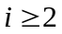 just as below.
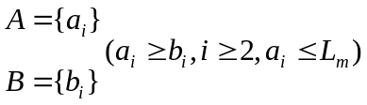 (10)
Since 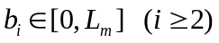, i is the labeled value of connected domain, creating histogram 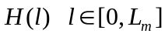 for the array B.
- Expectation Approach
Referring the concept of histogram in gray image threshold segmentation, we regard array B as “an image” with n pixels and 0~ gray level and build probability density histogram as below,
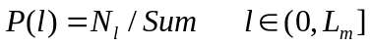 (11)
where,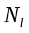is the number of which discrete statistical function value is l. Sum is the total number. We build the global connected domain threshold T by referring the concept of expectation algorithm in gray image segmentation.
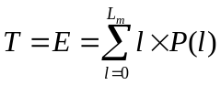 (12)
- Otsu Algorithm
By referring the concept of Otsu algorithm in gray image segmentation, we get the global connected-domain threshold 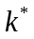. When the histogram is divided into two groups by a threshold, the value that can make the variance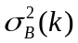 between the two groups become the biggest will be chosen as the connected domain threshold as below.
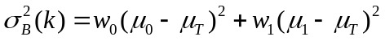 (13)
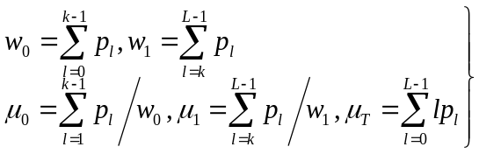 (14)
- Ratios
Because the array A and B can indirectly reflect the length and confidence attributes of the connected domains respectively. 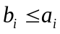, assume
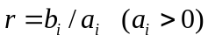 (15)
If r is less than 0.3 (variable parameter), then discard the corresponding connected-domain, otherwise keep the connected-domain.
- Experiment and Analysis
In the above two sections, we have discussed the steerable filter algorithm based on Gaussian function and the proposed threshold segmentation algorithm based on connected domain for the linear structure segmentation of medical images. Contrast experiments will be presented in this chapter.
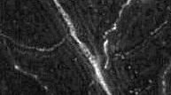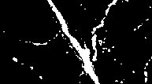
(a) Orignal image (b) result with Otsu

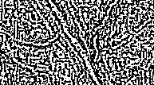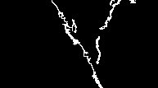
(c) result with NiBlack (d) result with Our Approach

Fig 5: Binary results without steerable filter processing

Fig 5 shows the effect of threshold segmentation without the preprocessing by steerable filter. From Fig 5(c), due to the noise interference, we can see that it causes NiBlack algorithm cannot maintain the connectivity on the linear structure. Therefore, the segmentation results are unsatisfactory for the original images like neural images without the preprocessing of steerable filter based on Gaussian function..

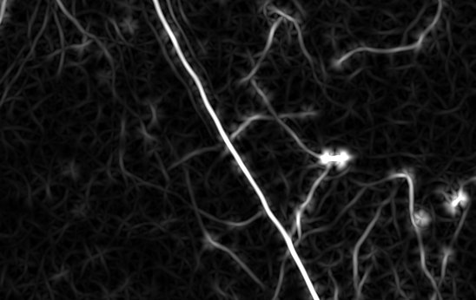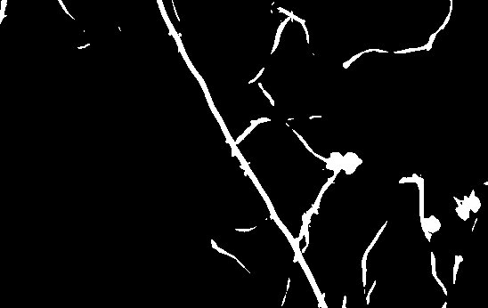
(a) steerable filter (b) (a) Otsu thresholding results

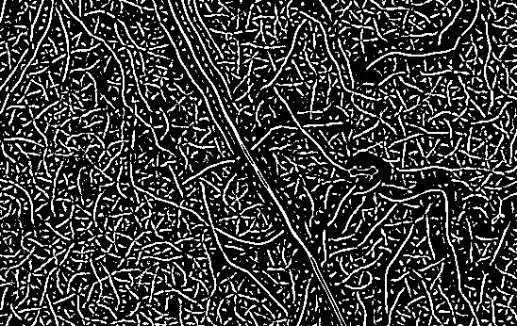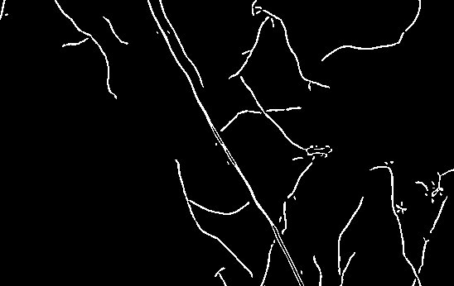
(c) (a) NiBlack thresholding (d) the expected Law article
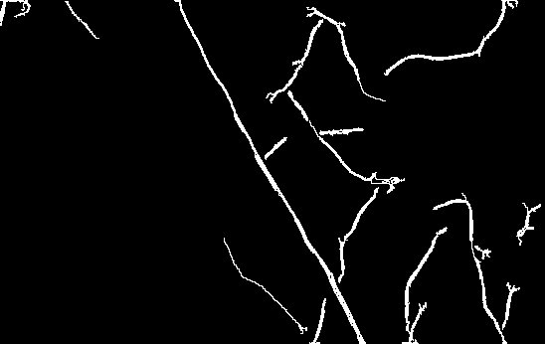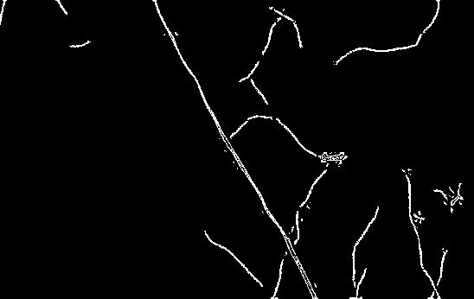
(e) This article Otsu law (f) ratio method herein
Fig 6: Binary method with steerable filter processing
Fig 6 shows the effect of the threshold segmentation of the image preprocessed by the steerable filter. After the preprocessing of steerable filter based on Gaussian function, the linear structure is smoother and the particle noises are well inhibited. It can be seen that our algorithm can well extract the linear structure of Fig 6 (c) just as shown in Fig 6(d),,(e) and (f).

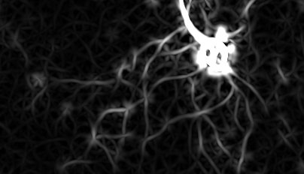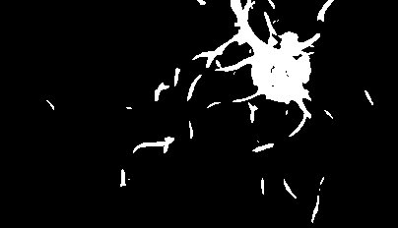
(a) Steerable filter (b) (a) Otsu

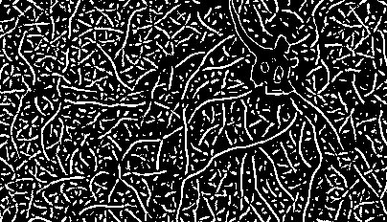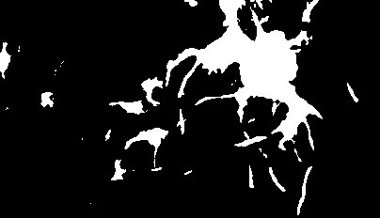
(c) (a) NiBlack (d) (a) level set

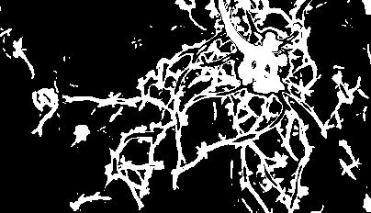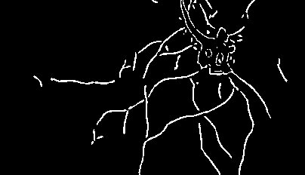
(e)(a) K-means (f) (a) algorithm

Fig 6: Comparison Experimental

5 Conclusion
According to the noise sensitive characteristics of the linear structure segmentation in the universal threshold segmentation algorithms. In this paper, we use the steerable filter algorithm based on Gaussian kernel to preprocess the image. In view of the traditional thresholding method, the linear structure of the medical image can not be well maintained with the global thresholding algorithm such as Otsu algorithm. And also, local threshold algorithm such as NiBlack algorithm which will cause a large number of noise We design several segmentation algorithms based on connected- domain to extract the linear structure in medical images, which takes full advantage of the linear smoothing and enhance features of steerable filter based on Gaussian kernel, as well as the strength of better linear structure connectivity when processing images with smooth boundary using local threshold segmentation method. After experiment, our algorithm can segment the linear structure in the medical images well.
References
- Baby, Anju Soosan, and K. Balachandran. "A parallel approach for region-growing segmentation." Computer Engineering and Applications (ICACEA), 2015 International Conference on Advances in. IEEE, 2015.
- Abdelsamea, Mohammed M. "An automatic seeded region growing for 2d biomedical image segmentation." arXiv preprint arXiv:1412.3958 (2014).
- Yi, Jaeyoun, and Jong Beom Ra. "A locally adaptive region growing algorithm for vascular segmentation." International Journal of Imaging Systems and Technology 13.4 (2003): 208-214.
- Djima, Karamatou A. Yacoubou, et al. "Detection of anomaly in human retina using Laplacian Eigenmaps and vectorized matched filtering." SPIE Medical Imaging. International Society for Optics and Photonics, 2015.
- Zhang, Bob, et al. "Retinal vessel extraction by matched filter with first-order derivative of Gaussian." Computers in biology and medicine 40.4 (2010): 438-445.
- Pang, Jincheng. The Level Set Method and Its Applications in Medical Image Analysis. Diss. TUFTS UNIVERSITY, 2015.
- Freeman, W. T., & Adelson, E. H. (1991). The design and use of steerable filters. IEEE Transactions on Pattern Analysis & Machine Intelligence, (9), 891-906.
- Jacob, M., & Unser, M. (2004). Design of steerable filters for feature detection using canny-like criteria. Pattern Analysis and Machine Intelligence, IEEE Transactions on, 26(8), 1007-1019.
- Jiang, Hui-Yan, Yue-peng Si, and Xing-gang Luo. "Medical Image Segmentation Based on Improved Ostu Algorithm and Regional Growth Algorithm." JOURNAL-NORTHEASTERN UNIVERSITY NATURAL SCIENCE 27.4 (2006): 398.
- Khurshid, Khurram, et al. "Comparison of Niblack inspired Binarization methods for ancient documents." IS&T/SPIE Electronic Imaging. International Society for Optics and Photonics, 2009.
- Bhuvaneswari, S., and T. S. Subashini. "Automatic Detection and Inpainting of Text Images." International Journal of Computer Applications (0975–8887) Volume (2013).

 *This work is supported by ******************

